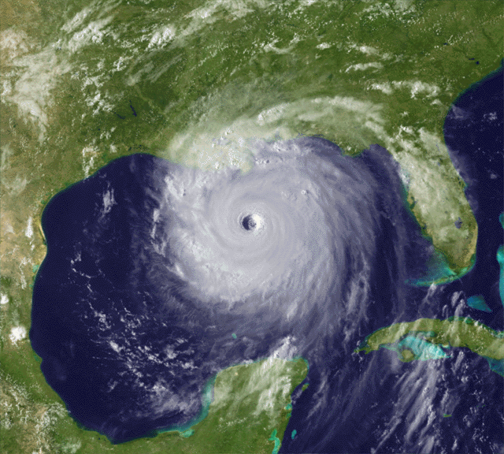Name_____________________________

To answer the following questions, reference the website below:

<http://flhurricane.com/cyclone/stormhistory.php?storm=12&year=2005>

Also use other online resources for research questions.

Use the excel spreadsheet template provided on my website for calculations.

Research the difference between lines of latitude and longitude? What direction do lines of latitude and longitude ***run*** on a map? What direction do lines of latitude and longitude ***measure*** on a map?

On an x-y coordinate plane, should the x-axis represent the latitude or the longitude? What should the y-axis represent?

Take a look at some of the latitude and longitude coordinates throughout the course of Hurricane Katrina on the suggested website. The latitude is measured in degrees North of the equator and the longitude is measured in degrees West of the Prime Meridian. In order to graph the hurricane path on the x-y coordinate plane in Excel, the North and West directions will be replaced by using either positive or negative values. Are degrees North of the equator positive or negative? Are degrees West of the Prime Meridian positive or negative?

Input the latitude and longitude values into the excel spreadsheet for advisories 1-7. Ignore the advisories 1A, 2A, etc. and only use the ones indicated in the provided Excel template. Add a trendline (select linear) to the data now shown on the scatterplot. ***Make sure to select Display Equation and Display R-squared value.*** Record the equation and the r-squared value below. (For directions on how to add a trendline to a set of data, refer to the video on my website.)

Research R-squared (as it applies to statistics) and write a definition. Cite your source (what website did you get this information?).

Based on your definition of r-squared, do you think a linear model was a good choice for this data? Explain.

Repeat the process of adding a trendline, but this time select a polynomial, order 2 (quadratic), model. Is this model more or less accurate than the linear model? Explain your reasoning.

Extend the two models to cover advisory points 1-11. Record the two new models (equations and r-squared values) below. Explain how significantly each of the two models was impacted. Which is the better model now? Why?

Extend the two models to cover advisory points 1-20. Record the two new models (equations and r-squared values) below. Explain how significantly each of the two models was impacted. Which is the better model now? Why?

Add a third trendline. This time select a polynomial order 3 (cubic) model. Is this model more or less accurate than the other models? Explain your reasoning.

What was the date of advisory 20?

Extend the three models to cover all advisory points listed in the Excel template. Record the three models below (equations and r-squared values). Which is the best model for the current path of this hurricane?

What was the date of advisory 26B? How much time did New Orleans have to evacuate?

Add a fourth trendline. This time select polynomial order 4 (quartic). Record the equation and r squared value of the model. Is this model more accurate than a cubic and if so, by how much? Would you recommend using this more complex model? Why or why not? (Hint: How much more accurate is it given how much more complex the model is?)

Research what makes hurricanes change paths so drastically and explain below. Cite your sources.